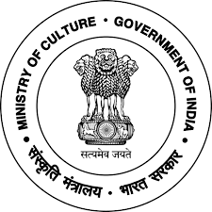
Registration Form

3rd Asian Philosophical Congress (APC)
&
93rd Indian Philosophical Congress (IPC)
^{on}
“Paradigm of Peace and Prosperity”
(7th to 11th March, 2019)

Hosted by
Nava Nalanda Mahavihara
(Deemed University),
Ministry of Culture, Govt. of India, Nalanda

1. Full Name (In Capital):

2. Designation:

3. Attending in APC / IPC
4. University / College / Institution Address:

5. Home / House Address:

6. Mobile No.:
7. E-Mail:
8. Topic of Research Paper:

(Signature)

